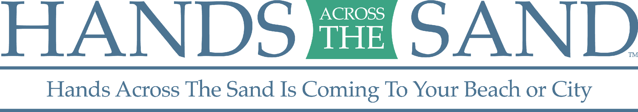
FOR IMMEDIATE RELEASE
May 13, 2019
******* MEDIA ADVISORY *******

“HANDS ACROSS THE SAND/LAND” GATHERINGS SET FOR 87 LOCATIONS WORLDWIDE ON MAY 18TH

Activists to gather in costal areas to stand up against offshore drilling; local events scheduled for CA, CT, DE, DC, FL, GA, ME, MD, MA, NH, NJ, NY, NC, SC, VA and WA

WHO: Local, national, and international conservation groups are organizing demonstrations against offshore drilling in the waters off the East Coast, West Coast, Gulf of Mexico and Alaska. The groups include: Oceana, Surfrider Foundation, Southern Alliance for Clean Energy, Sierra Club, Natural Resources Defense Council, League of Conservation Voters, Earthjustice, Bud and Alley’s, SoWal, Urban Paradise Guild and Healthy Gulf.

WHAT: Crowds will join hands forming lines across beaches, parks and state capitol steps in synchronized "Hands Across the Sand/Land" demonstrations. This includes 87 synchronized events across 15 states and five countries to raise awareness about the dangers of dirty fuels and the need to accelerate the transition to available, affordable clean energy solutions. The show of opposition this year comes at a time when the Trump administration is facing significant legal hurdles in its moves to expand offshore drilling. The administration made a preliminary proposal last year to expand offshore drilling to nearly all of America’s coastlines, and has issued a first set of permits for oil and gas exploration along the Atlantic coast.

WHEN: Saturday, May 18th at noon local time (media check in: 11:30 am local time).
WHERE: Across 15 states, the District of Columbia and five total countries, groups will hold 87 synchronized events. 28 events will be held in Florida. Additional events in CA, DE, DC, CA, CT, GA, ME, MD, MA, NH, NJ, NY, NC, SC, VA and WA For a full list of events and locations visit: http://www.handsacrossthesand.org.

WHY: Hands Across the Sand participants will urge more local elected officials to formally oppose the Trump administration’s draft plan to expand offshore drilling and to take a stronger stand against the expansion of offshore drilling along the coast. Drilling offshore is investing in a dirty energy past, instead of a clean energy future. The impacts of dirty and dangerous offshore drilling threaten people across the world.
*** VISUALS WILL INCLUDE A LARGE GROUP OF CITIZENS JOINING HANDS AT EVENT LOCATIONS, SIGNS ***

** INTERVIEW AND PHOTO / VIDEO OPPORTUNITIES AVAILABLE**

MEDIA CONTACT: Alex Frank, (703) 276-3264, afrank@hastingsgroup.com

###

Floridian Dave Rauschkolb founded Hands Across the Sand/Land in October 2009. Hands Across the Sand/Land is sponsored by national environmental organizations and others including; Oceana, Surfrider Foundation, Southern Alliance for Clean Energy, Sierra Club, Natural Resources Defense Council, League of Conservation Voters, Earthjustice, SoWal, Healthy Gulf, Urban Paradise Guild and Bud and Alley’s.

