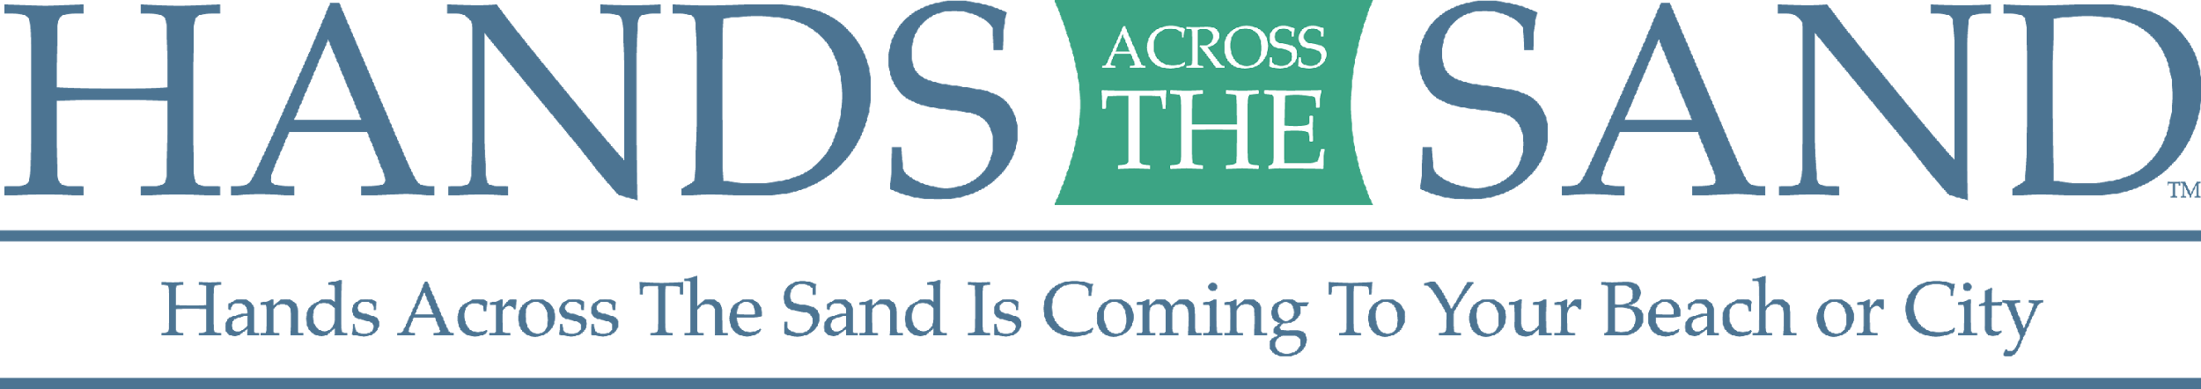

PRESS STATEMENT
FROM DAVE RAUSCHKOLB,
FOUNDER OF HANDS ACROSS THE SAND / LAND

I founded Hands Across the Sand to bring organizations and individuals together to send a powerful message to leaders that expanding oil drilling in our oceans is a dirty, dangerous endeavor.

We must compel our local and national lawmakers to steer a clear path towards clean energy sources and decrease our dependence on dirty, dangerous fuels. Every oil spill endangers the coastal tourism industries, ravages the sea life and seafood industry and impacts the lives of every person in its path for generations after.
I founded Hands Across The Sand in October 2009 in response to a bill passed in the Florida House of Representatives that would lift a ban on near shore drilling. With the support of sponsor organizations, we rallied more than 10,000 Floridians to join hands on Feb. 13, 2010, to show a united opposition to near shore drilling. The event covered the state’s coastlines, from the Atlantic to the Gulf. As a result of these efforts, the bill was tabled the next month.

Two months later the BP Deepwater Horizon exploded in the Gulf of Mexico. We then organized a global Hands Across The Sand to urge President Barack Obama to abandon his bid to open the continental United States waters to offshore oil drilling.
Hands Across the Sand is held annually to bring awareness about the dangers inherent in securing and burning dirty fuels and to champion a new era of Clean Energy for a sustainable planet for our children and theirs. My sister, Dede Shelton, has been the Executive Director since 2011, along with the guidance and support from our board and amazing long-term sponsors.
If we learned anything from the Deepwater Horizon disaster it is:
There is no such thing as cleaning up an oil spill.
We have since added land issues such as hydraulic fracturing, mountain top clearing and coal. We are all complicit in the slow death we are inflicting on our oceans and earth. We must join hands and weave a thread of balance and wisdom for our planet. We have done our damage; we now have the power to undo, and together, build a clean energy path that sustains us all. There is no more important issue we must focus on as humans. Join hands with us all over the world!

www.handsacrossthesand.org
https://www.facebook.com/HandsAcrossTheSand
Over 50,000 members and climbing.

