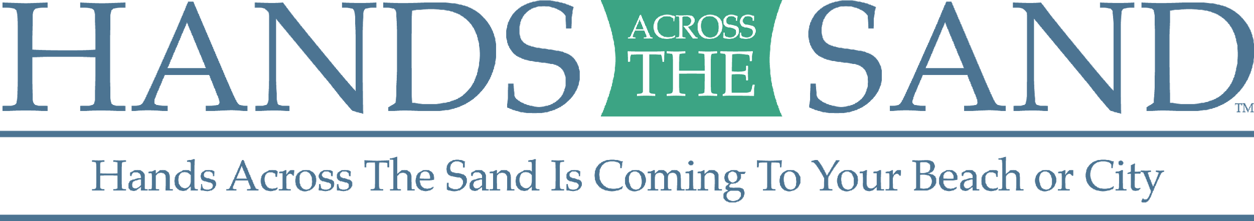

Hands Across the Sand/ Land Sample Op-Ed

Guidelines:
- Know the word limit for your paper, most are between 600-800
- Make this piece your own! This is a sample op-ed, be sure to share personal stories that are pertinent to your community.
- Research information on your cause – land or sand.
- Visit http://www.beachapedia.org/Offshore_Oil_Drilling to find regional and state-specific facts on offshore drilling.
- Provide an eye-catching title.
- Check your local paper’s website, most have an option for submitting op-eds and letters to the editor online.
- Other Resources
  - Visit www.oceaneconomics.org/Market/coastal/coastalEcon.asp to find regional and state-specific facts on economic contributions from tourism and recreation
  - Visit http://www.st.nmfs.noaa.gov/economics/publications/feus/fisheries_economics_2010 to find state-specific facts on economic contributions from recreational and commercial fishing
  - Visit this National Marine Fisheries Service study to find the most recent national and statewide data on economic sales impacts of recreational fishing

EXAMPLE OP-ED

Breaking Our Oil Addiction

On May 18th 2019, [INSERT STATE] will once again join hands to express opposition to dirty fuels, and support for clean energy. Hands Across the Sand/Land is a movement made up of people from all walks of life. We are parents, friends, neighbors, small business owners, and sportsmen. We span political lines, geographic boundaries, and socio-economic groups. We are united by the desire to protect our coastal economies, oceans, wildlife, fisheries, our environment and our way of life.

Offshore drilling is dirty, dangerous, and unsustainable. With 781 spills reported by the U.S. Bureau of Safety and Environmental Enforcement from 1995-2013, it is only a matter of time before the next catastrophic spill. Recreational saltwater fishing in Florida provides over 98,000 jobs and has an economic sales impact of $10.5 billion. That’s just a drop in the bucket compared to Florida’s $57 billion tourism industry. Our coastal resources are simply too great to risk another Deepwater Horizon disaster.

Hands Across the Sand is about embracing energy sources that will sustain our planet. A clean energy policy is the path to job growth, a vibrant economic future, improved international relations, and long-term energy independence. New clean energy, in combination with reduced consumption, will help us break our addiction to fossil fuels. We are sponsored by Oceana, Surfrider, Sierra Club, Southern Alliance for Clean Energy, SoWal, Earth Ethics and Gulf Restoration Network and Another Gulf is Possible.

[INSERT LOCAL STORY, NO MORE THAN 150-200 WORDS]

Across the state, across the nation, and around the world, we join hands for future generations. We join hands so they will know the beauty of our shores, catching the perfect wave, or reeling in the big one. We join hands on May 18th to protect what we love.

Please join us at [INSERT EVENT INFO] on May 18th at noon. Join hands to say no to filthy fossil fuels, and yes to a safe, healthy, and sustainable future with clean energy.

[NAME]
[TITLE]
[CONTACT INFO]

