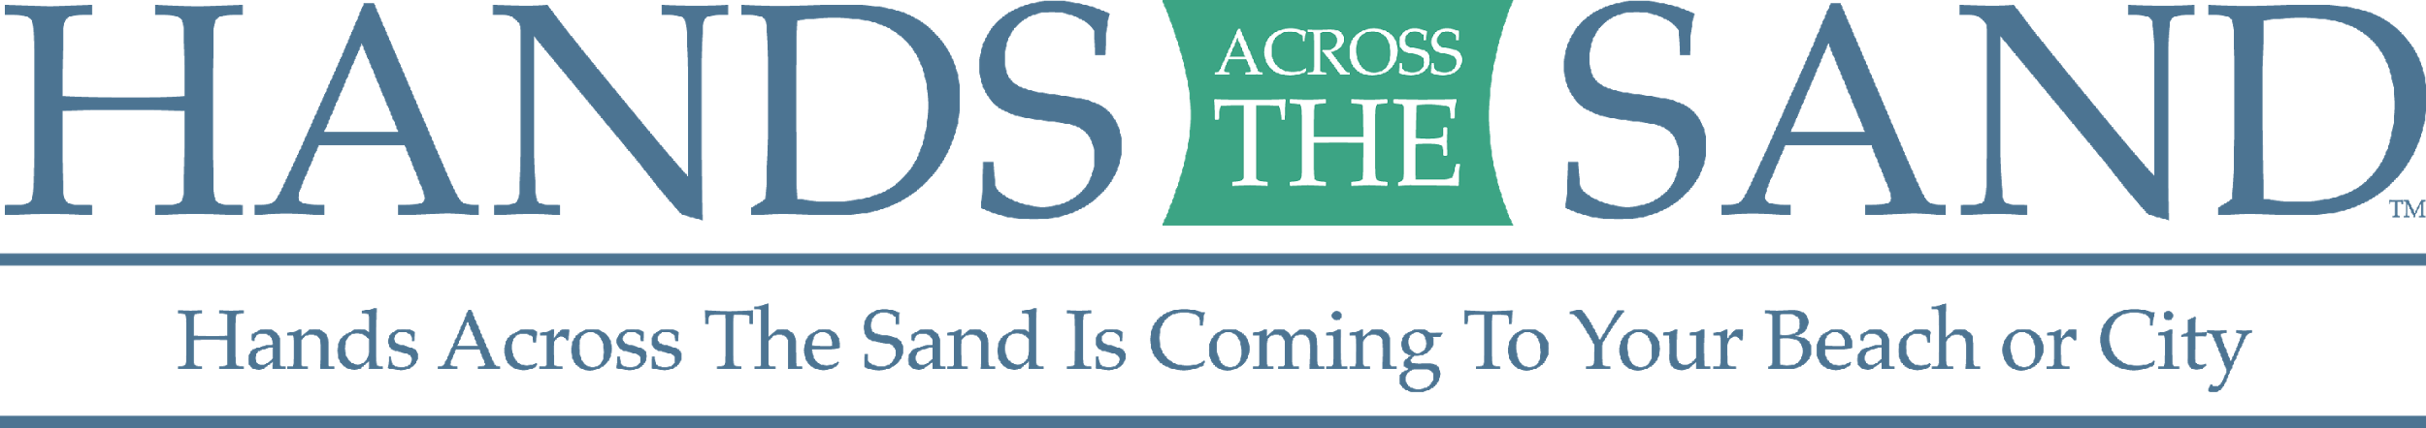
FOR IMMEDIATE RELEASE
DATE XXXXXX
Contact: Name, Organization, Phone, Email
******* MEDIA ADVISORY *******

HANDS ACROSS THE SAND/LAND COMING TO [TOWN] ON MAY 19TH

WHO: (list of groups) is organizing a protest against planned drilling for oil and gas off the coast of (State) is be organized by. [List any VIPs that will be attending/ speaking. For more information, go to www.handsacrossthesands.org.

WHAT: A sizable crowd will join hands forming a line across the [beach/park/capitol steps] in a local "Hands Across the Sand/Land" gathering. This is one of 113 synchronized events across 17 states and seven countries to raise awareness about the dangers of dirty fuels and the need to speed the transition to available, affordable clean energy solutions. The events are particularly salient this year with the Trump Administration’s draft plan to expand offshore drilling to almost every square inch of the American coastline and assault on public lands.

WHEN: Saturday, May 19th at noon (media check in at 11:30 am)
WHERE: ADDRESS OF EVENT AND EXACT LOCATION

WHY: Drilling off the coast of (State) is the opposite of investing in a green energy future and fails to honor international agreements to fight climate change. The impacts of these actions will affect people across the world. Hands Across the Sand participants will specifically be pushing local elected officials to formally oppose the draft plan to expand offshore drilling if they have not done so already and to take a stronger stand against the expansion of offshore drilling along the coast.
***VISUALS WILL INCLUDE A LARGE GROUP OF CITIZENS JOINING HANDS AT THEIR EVENT LOCATIONS, SIGNS, [LIST ANY OTHER VISUALS]
** INTERVIEW AND PHOTO/ VIDEO OPPORTUNITIES AVAILABLE**
###
Floridian Dave Rauschkolb founded Hands Across the Sand/Land in October 2009. Hands Across the Sand/Land is sponsored by national environmental organizations including Oceana, Surfrider Foundation, Southern Alliance for Clean Energy, Sierra Club, Earth Ethics, Center for Biological Diversity, Another Gulf is Possible, Redfin and Gulf Restoration Network.

