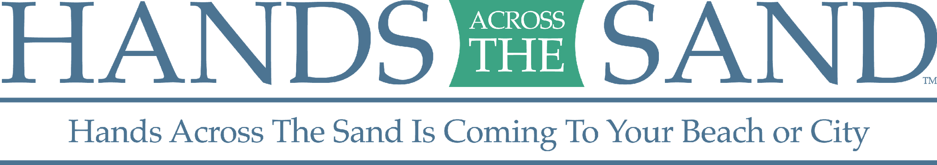

Contact:
Dede Shelton, Executive Director
pressinfo@handsacrossthesand.org

FOR IMMEDIATE RELEASE:
On May 19th 2018 at noon in corresponding time zones, people around the world will join hands on beaches and in cities for the eighth annual Hands Across The Sand to oppose expanded offshore drilling, hydraulic fracking, mountain top clearing, coal plants and tar sands, and to call for clean energy solutions for a sustainable planet.

Hands Across The Sand is a movement made of people of all walks of life and crosses all borders and political affiliations. It is about supporting the advancement of clean energy sources that will sustain our planet. This movement is not about politics; it is about protecting coastal economies, oceans, marine wildlife and fisheries from the threats of expanded offshore drilling and the accidents associated with that drilling. It is about protecting our groundwater from carcinogenic chemicals used in fracking and protecting our lands from oil spills.

Hands Across The Sand participants are joining hands on May 19th to say NO to the use of filthy fuels and YES to clean energy. They are joining hands to implore leaders and decision-makers to end the world’s dependence on oil and coal and embrace a clean energy future for a sustainable planet.

Florida surfer and restaurateur Dave Rauschkolb founded Hands Across The Sand in October 2009 in response to a bill passed in the Florida House of Representatives that would lift a ban on near shore drilling. With the support of sponsor organizations, he rallied more than 10,000 Floridians to join hands on Feb. 13, 2010, to show a united opposition to near shore drilling. The event covered the state’s coastlines, from the Atlantic to the Gulf. As a result of their efforts, the bill was tabled the next month. Two months later the BP Deepwater Horizon exploded in the Gulf of Mexico. Dave then organized a global Hands Across The Sand to urge former President Barack Obama to abandon his bid to open the continental United States waters to offshore oil drilling.

Since our incipiency, thousands of events have taken place in all 50 United States, the District of Columbia and Puerto Rico. International events have been held in 42 countries including Australia, Bangladesh, Brazil, Belize, Canada, China, Colombia, Costa Rica, Germany, Denmark, Dominican Republic, Ecuador, Spain, France, United Kingdom, Greenland, Greece, Croatia, Ireland, India, Italy, Egypt, Nepal, Japan, South Korea, Lebanon, Mexico, Malaysia, Nicaragua, Netherlands, Norway, New Zealand, Panama, Peru, Poland, Romania, Sweden, Turkey, Tanzania, and South Africa.

Hands Across the Sand added land issues to its focus over time, including hydraulic fracking, the Keystone XL Pipeline, tar sands mining, mountaintop removal mining and coal fired power plants. Hands is dedicated to taking a stand for clean energy and bringing people together to create a powerful image of solidarity.

Website: www.handsacrossthesand.org
Flickr Photo stream for event photos: http://www.flickr.com/search/groups/show/?q=handsacrossthesand&m=po
ol&w=1467020%40N23

Background: Floridian Dave Rauschkolb founded Hands Across The Sand/Land in October 2009. Hands Across The Sand/Land is endorsed by national and local organizations: Surfrider Foundation, Southern Alliance for Clean Energy, Oceana, Sierra Club, Earth Ethics, Gulf Restoration Network, Friends Of the Earth and Earth Ethics. In-kind supporters are Urban Paradise Guild and Michigan Citizens for Water Conservation.

